# Editorial universitaria a GA4

dfAgrupacionCanales Index(['Fecha', 'Grupo de canales predeterminado de la sesión', 'Vistas'], dtype='object')

Index(['Fecha', 'Agrupación de canales predeterminada',

'Número de vistas de página'],

dtype='object')

lista_tags_unicos ['Organic Search' 'Direct' 'Referral' 'Organic Social' 'Unassigned'

'Organic Video']

dfsisOperativo Index(['Fecha', 'Sistema operativo', 'Vistas'], dtype='object')

lista_tags_unicos ['Android' 'Windows' 'Macintosh' 'iOS' 'Linux' 'Chrome OS' 'Playstation 4'

'Sistema operativo (not set)']

dfPais Index(['Fecha', 'País', 'Vistas'], dtype='object')

lista_tags_unicos ['Argentina', 'Otros Paises']

dfCategoriaDispositivo Index(['Fecha', 'Categoría de dispositivo', 'Vistas'], dtype='object')

lista_tags_unicos ['mobile' 'desktop' 'tablet' 'smart tv']

dfTotales Index(['Fecha', 'Número de vistas de página', 'Usuarios nuevos', 'Usuarios',

'Número de sesiones por usuario', 'Sesiones'],

dtype='object')

# Columnas de Tum Transmedia

['Predictor Flag', 'Número de vistas de página', 'Usuarios nuevos',

'Usuarios', 'Número de sesiones por usuario', 'Sesiones', 'Argentina',

'Otros Paises', 'mobile', 'desktop', 'tablet',

'Categoría de dispositivo promedio', 'Categoría de dispositivo std',

'Windows', 'Android', 'Linux', 'Macintosh',

'Sistema operativo (not set)', 'iOS', 'Windows Phone', 'Chrome OS',

'Tizen', 'Sistema operativo promedio', 'Sistema operativo std',

'Organic Search', 'Social', 'Direct', 'Referral',

'Agrupación de canales predeterminada promedio',

'Agrupación de canales predeterminada std', 'mes', 'correlacion anual',

'correlacion Trimestral']

Sklear knn

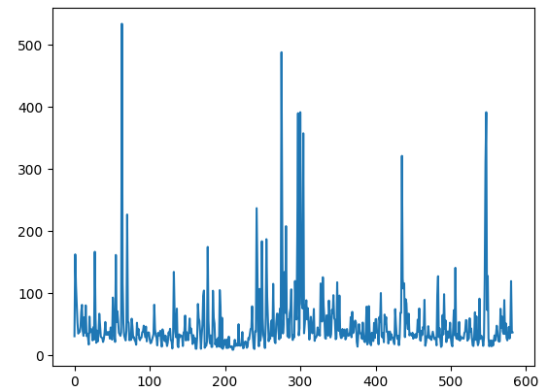

Filtrado por 400

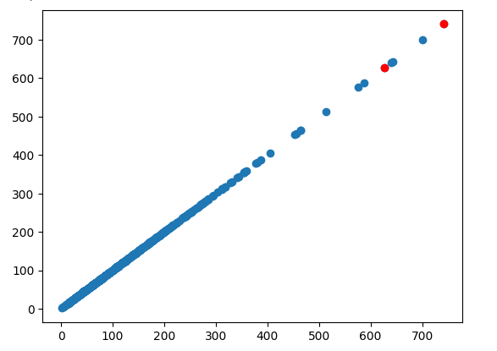

# Prueba 80-20

Evaluate on test data

6/6 [==============================] - 1s 19ms/step - loss: 0.5983

test loss 0.5983048677444458

Reentrenado

Comienza 2024-01-30 16:46:34

Finaliza 2024-01-30 16:50:13

best score 0.568002

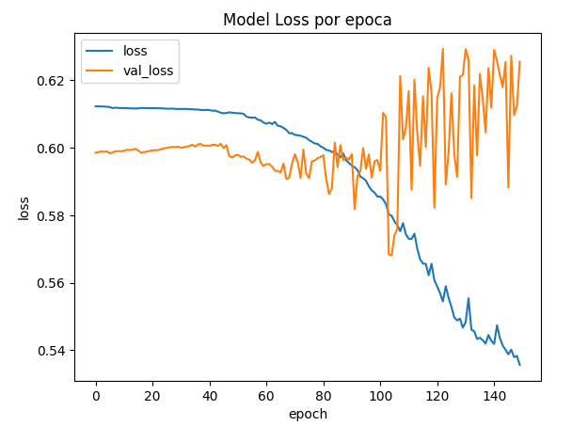

# Especificaciones de la pc

!df -h

Filesystem Size Used Avail Use% Mounted on

overlay 79G 27G 52G 34% /

tmpfs 64M 0 64M 0% /dev

shm 5.7G 0 5.7G 0% /dev/shm

/dev/root 2.0G 1.1G 849M 57% /usr/sbin/docker-init

tmpfs 6.4G 212K 6.4G 1% /var/colab

/dev/sda1 75G 56G 20G 75% /opt/bin/.nvidia

tmpfs 6.4G 0 6.4G 0% /proc/acpi

tmpfs 6.4G 0 6.4G 0% /proc/scsi

tmpfs 6.4G 0 6.4G 0% /sys/firmware

drive 15G 13G 2.8G 82% /content/drive

!cat /proc/cpuinfo

processor : 0

vendor_id : GenuineIntel

cpu family : 6

model : 79

model name : Intel(R) Xeon(R) CPU @ 2.20GHz

stepping : 0

microcode : 0xffffffff

cpu MHz : 2199.998

cache size : 56320 KB

physical id : 0

siblings : 2

core id : 0

cpu cores : 1

apicid : 0

initial apicid : 0

fpu : yes

fpu_exception : yes

cpuid level : 13

wp : yes

flags : fpu vme de pse tsc msr pae mce cx8 apic sep mtrr pge mca cmov pat pse36 clflush mmx fxsr sse sse2 ss ht syscall nx pdpe1gb rdtscp lm constant_tsc rep_good nopl xtopology nonstop_tsc cpuid tsc_known_freq pni pclmulqdq ssse3 fma cx16 pcid sse4_1 sse4_2 x2apic movbe popcnt aes xsave avx f16c rdrand hypervisor lahf_lm abm 3dnowprefetch invpcid_single ssbd ibrs ibpb stibp fsgsbase tsc_adjust bmi1 hle avx2 smep bmi2 erms invpcid rtm rdseed adx smap xsaveopt arat md_clear arch_capabilities

bugs : cpu_meltdown spectre_v1 spectre_v2 spec_store_bypass l1tf mds swapgs taa mmio_stale_data retbleed

bogomips : 4399.99

clflush size : 64

cache_alignment : 64

address sizes : 46 bits physical, 48 bits virtual

power management:

processor : 1

vendor_id : GenuineIntel

cpu family : 6

model : 79

model name : Intel(R) Xeon(R) CPU @ 2.20GHz

stepping : 0

microcode : 0xffffffff

cpu MHz : 2199.998

cache size : 56320 KB

physical id : 0

siblings : 2

core id : 0

cpu cores : 1

apicid : 1

initial apicid : 1

fpu : yes

fpu_exception : yes

cpuid level : 13

wp : yes

flags : fpu vme de pse tsc msr pae mce cx8 apic sep mtrr pge mca cmov pat pse36 clflush mmx fxsr sse sse2 ss ht syscall nx pdpe1gb rdtscp lm constant_tsc rep_good nopl xtopology nonstop_tsc cpuid tsc_known_freq pni pclmulqdq ssse3 fma cx16 pcid sse4_1 sse4_2 x2apic movbe popcnt aes xsave avx f16c rdrand hypervisor lahf_lm abm 3dnowprefetch invpcid_single ssbd ibrs ibpb stibp fsgsbase tsc_adjust bmi1 hle avx2 smep bmi2 erms invpcid rtm rdseed adx smap xsaveopt arat md_clear arch_capabilities

bugs : cpu_meltdown spectre_v1 spectre_v2 spec_store_bypass l1tf mds swapgs taa mmio_stale_data retbleed

bogomips : 4399.99

clflush size : 64

cache_alignment : 64

address sizes : 46 bits physical, 48 bits virtual

power management:

!cat /proc/meminfo

MemTotal: 13290472 kB

MemFree: 7876324 kB

MemAvailable: 11952156 kB

Buffers: 346404 kB

Cached: 3913960 kB

SwapCached: 0 kB

Active: 755892 kB

Inactive: 4337756 kB

Active(anon): 1272 kB

Inactive(anon): 833532 kB

Active(file): 754620 kB

Inactive(file): 3504224 kB

Unevictable: 16 kB

Mlocked: 16 kB

SwapTotal: 0 kB

SwapFree: 0 kB

Dirty: 2292 kB

Writeback: 0 kB

AnonPages: 831264 kB

Mapped: 640980 kB

Shmem: 1512 kB

KReclaimable: 116176 kB

Slab: 158932 kB

SReclaimable: 116176 kB

SUnreclaim: 42756 kB

KernelStack: 5664 kB

PageTables: 13576 kB

SecPageTables: 0 kB

NFS_Unstable: 0 kB

Bounce: 0 kB

WritebackTmp: 0 kB

CommitLimit: 6645236 kB

Committed_AS: 2848400 kB

VmallocTotal: 34359738367 kB

VmallocUsed: 76012 kB

VmallocChunk: 0 kB

Percpu: 1088 kB

HardwareCorrupted: 0 kB

AnonHugePages: 4096 kB

ShmemHugePages: 0 kB

ShmemPmdMapped: 0 kB

FileHugePages: 0 kB

FilePmdMapped: 0 kB

CmaTotal: 0 kB

CmaFree: 0 kB

Unaccepted: 0 kB

HugePages_Total: 0

HugePages_Free: 0

HugePages_Rsvd: 0

HugePages_Surp: 0

Hugepagesize: 2048 kB

Hugetlb: 0 kB

DirectMap4k: 142136 kB

DirectMap2M: 3000320 kB

DirectMap1G: 12582912 kB

!/usr/local/cuda/bin/nvcc --version

nvcc: NVIDIA (R) Cuda compiler driver

Copyright (c) 2005-2023 NVIDIA Corporation

Built on Tue_Aug_15_22:02:13_PDT_2023

Cuda compilation tools, release 12.2, V12.2.140

Build cuda_12.2.r12.2/compiler.33191640_0

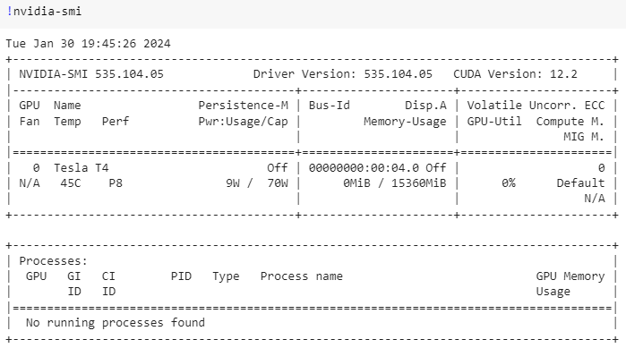

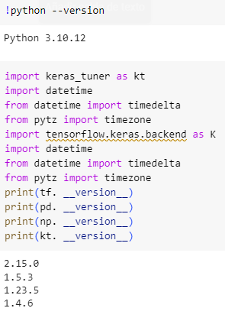

# Prueba 70-30

Comienza 2024-01-30 17:08:30

Finaliza 2024-01-30 17:13:00

best score 0.590801

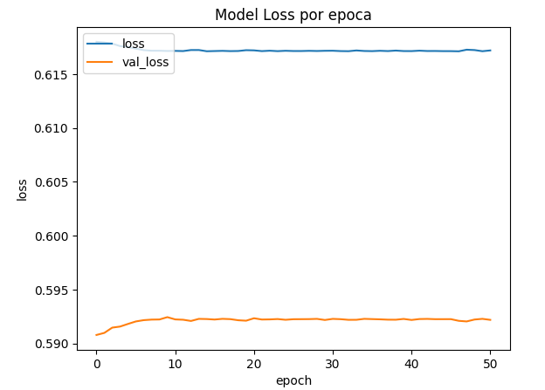

!df -h

Filesystem Size Used Avail Use% Mounted on

overlay 79G 27G 52G 34% /

tmpfs 64M 0 64M 0% /dev

shm 5.7G 0 5.7G 0% /dev/shm

/dev/root 2.0G 1.1G 849M 57% /usr/sbin/docker-init

tmpfs 6.4G 124K 6.4G 1% /var/colab

/dev/sda1 75G 56G 20G 75% /opt/bin/.nvidia

tmpfs 6.4G 0 6.4G 0% /proc/acpi

tmpfs 6.4G 0 6.4G 0% /proc/scsi

tmpfs 6.4G 0 6.4G 0% /sys/firmware

drive 15G 13G 2.5G 84% /content/drive

!cat /proc/cpuinfo

processor : 0

vendor_id : GenuineIntel

cpu family : 6

model : 79

model name : Intel(R) Xeon(R) CPU @ 2.20GHz

stepping : 0

microcode : 0xffffffff

cpu MHz : 2199.998

cache size : 56320 KB

physical id : 0

siblings : 2

core id : 0

cpu cores : 1

apicid : 0

initial apicid : 0

fpu : yes

fpu_exception : yes

cpuid level : 13

wp : yes

flags : fpu vme de pse tsc msr pae mce cx8 apic sep mtrr pge mca cmov pat pse36 clflush mmx fxsr sse sse2 ss ht syscall nx pdpe1gb rdtscp lm constant_tsc rep_good nopl xtopology nonstop_tsc cpuid tsc_known_freq pni pclmulqdq ssse3 fma cx16 pcid sse4_1 sse4_2 x2apic movbe popcnt aes xsave avx f16c rdrand hypervisor lahf_lm abm 3dnowprefetch invpcid_single ssbd ibrs ibpb stibp fsgsbase tsc_adjust bmi1 hle avx2 smep bmi2 erms invpcid rtm rdseed adx smap xsaveopt arat md_clear arch_capabilities

bugs : cpu_meltdown spectre_v1 spectre_v2 spec_store_bypass l1tf mds swapgs taa mmio_stale_data retbleed

bogomips : 4399.99

clflush size : 64

cache_alignment : 64

address sizes : 46 bits physical, 48 bits virtual

power management:

processor : 1

vendor_id : GenuineIntel

cpu family : 6

model : 79

model name : Intel(R) Xeon(R) CPU @ 2.20GHz

stepping : 0

microcode : 0xffffffff

cpu MHz : 2199.998

cache size : 56320 KB

physical id : 0

siblings : 2

core id : 0

cpu cores : 1

apicid : 1

initial apicid : 1

fpu : yes

fpu_exception : yes

cpuid level : 13

wp : yes

flags : fpu vme de pse tsc msr pae mce cx8 apic sep mtrr pge mca cmov pat pse36 clflush mmx fxsr sse sse2 ss ht syscall nx pdpe1gb rdtscp lm constant_tsc rep_good nopl xtopology nonstop_tsc cpuid tsc_known_freq pni pclmulqdq ssse3 fma cx16 pcid sse4_1 sse4_2 x2apic movbe popcnt aes xsave avx f16c rdrand hypervisor lahf_lm abm 3dnowprefetch invpcid_single ssbd ibrs ibpb stibp fsgsbase tsc_adjust bmi1 hle avx2 smep bmi2 erms invpcid rtm rdseed adx smap xsaveopt arat md_clear arch_capabilities

bugs : cpu_meltdown spectre_v1 spectre_v2 spec_store_bypass l1tf mds swapgs taa mmio_stale_data retbleed

bogomips : 4399.99

clflush size : 64

cache_alignment : 64

address sizes : 46 bits physical, 48 bits virtual

power management:

!cat /proc/meminfo

MemTotal: 13290472 kB

MemFree: 7901388 kB

MemAvailable: 12014096 kB

Buffers: 346004 kB

Cached: 3950564 kB

SwapCached: 0 kB

Active: 753800 kB

Inactive: 4332236 kB

Active(anon): 1172 kB

Inactive(anon): 789724 kB

Active(file): 752628 kB

Inactive(file): 3542512 kB

Unevictable: 16 kB

Mlocked: 16 kB

SwapTotal: 0 kB

SwapFree: 0 kB

Dirty: 2536 kB

Writeback: 0 kB

AnonPages: 787864 kB

Mapped: 638588 kB

Shmem: 1420 kB

KReclaimable: 117332 kB

Slab: 160012 kB

SReclaimable: 117332 kB

SUnreclaim: 42680 kB

KernelStack: 5648 kB

PageTables: 12284 kB

SecPageTables: 0 kB

NFS_Unstable: 0 kB

Bounce: 0 kB

WritebackTmp: 0 kB

CommitLimit: 6645236 kB

Committed_AS: 2868940 kB

VmallocTotal: 34359738367 kB

VmallocUsed: 76028 kB

VmallocChunk: 0 kB

Percpu: 1088 kB

HardwareCorrupted: 0 kB

AnonHugePages: 2048 kB

ShmemHugePages: 0 kB

ShmemPmdMapped: 0 kB

FileHugePages: 0 kB

FilePmdMapped: 0 kB

CmaTotal: 0 kB

CmaFree: 0 kB

Unaccepted: 0 kB

HugePages_Total: 0

HugePages_Free: 0

HugePages_Rsvd: 0

HugePages_Surp: 0

Hugepagesize: 2048 kB

Hugetlb: 0 kB

DirectMap4k: 144184 kB

DirectMap2M: 4046848 kB

DirectMap1G: 11534336 kB

!/usr/local/cuda/bin/nvcc --version

nvcc: NVIDIA (R) Cuda compiler driver

Copyright (c) 2005-2023 NVIDIA Corporation

Built on Tue_Aug_15_22:02:13_PDT_2023

Cuda compilation tools, release 12.2, V12.2.140

Build cuda_12.2.r12.2/compiler.33191640_0

